Investment RoboAdvisor

**Professor:**

Dr. Seshasai Srinivasan

**Team members:**

Qin Yang 400420584 [yangq90@mcmaster.ca](mailto:yangq90@mcmaster.ca)

Hua Yao 400344368 [yaoh17@mcmaster.ca](mailto:yaoh17@mcmaster.ca)

Abubakir Myrzaly 400268356 [myrzalya@mcmaster.ca](mailto:myrzalya@mcmaster.ca)

Hongliang Wang 400220416 [wangh258@mcmaster.ca](mailto:wangh258@mcmaster.ca)

Project Repository: https://github.com/Edward0728/RoboAdvisor_4FD3

## Abstract

RoboAdvisor is a chatbot which aims to provide non-professional investors with straightforward and simple recommendations on the Canadian stock and mutual fund market. RoboAdvisor is based as a Flask web app empowered by LSTM model. RoboAdvisor has the ability to inquiry users’ info and investment objective, and then provides list of stocks and mutual funds. The performance of chat bot heavily depends on the Machine Learning training. With that been said, we focus on creating the MVP(Minimum Viable Product) in this project. The more training the RoboAdvisor gets, the more intelligent it is.

In this report, more details of RoboAdvisor, such as project overview and objectives and project requirements. We will also showcase the design of RoboAdvisor and explain the challenge we were facing.

## Project Description

### Project overview

This project is to create a chat bot that, RoboAdvisor, can perform repetitive work. Roboadvisor asks users questions regarding their risk appetite, fund size preference, investment return expectation, and volatility tolerance as inputs. The backend algorithms will use these inputs to search in the updated product database and give funds matching the user’s requirements.

This project experienced two main stages. In the first half semester, research such as financial databases and application tech stack were conducted. Chat bot skeleton, backend APIs, and web app skeleton were developed. In the second half semester, more advanced features using more algorithms would be integrated to provide more valuable solutions for the users. The chatbot was trained to take user inquiry. Backend APIs were integrated to the web app frontend.

### Objectives

Everytime we will be asked a certain question when we visit a new financial advisor in a bank. For example, our income, risk tolerance, ROI(Rate Of Investment) expectation, and so on. Upon our response, the advisor will search in the database and recommend some qualified stocks, mutual funds, or other financial products.

The objective of this project is to train a chatbot to perform the tasks described above. By chatting with the bot, the user could quickly get the product recommendation fitting their situation. This helps users avoid subscription to financial websites, look into hundreds of products, and manually filter the products without much investment knowledge.

## Requirements

### Product use cases

Users can interact with robo advisor and obtain investment information.

RoboAdvisor provides financial planning services that are automated with algorithms without any human control.

RoboAdvisor uses passive index investing strategies to provide the necessary investment advice that many new people are struggling with nowadays.

The RoboAdvisor works in the following ways as demoed in the following diagram. Users have to register and log in the web app, and then provide necessary info by chatting with RoboAdvisor. Once RoboAdvisor gathers client information, it will automatically provide advices to the client based on those answers.

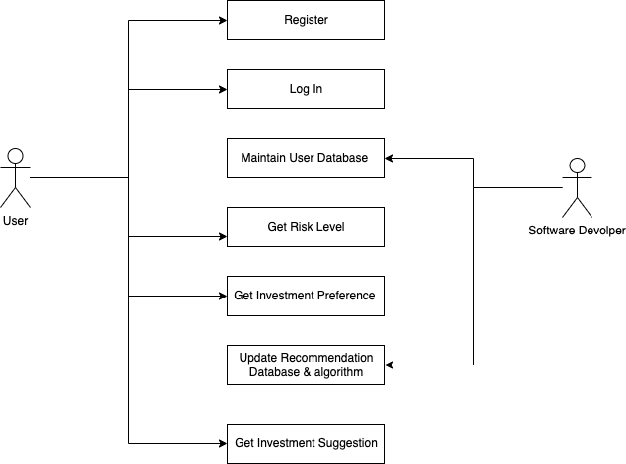

### Functional requirements

RoboAdvisor provides a list of recommended mutual funds including names and selected information such as year rate of return after it gets necessary users’ input. Details of functional requirements are listed below.

Frontend:

* Chatbot is able to interact with users
* Chatbot database is trained precisely for user case
* The investment can be presented to the user in clear format.
* Users should be able to register and log in

Backend:

* Backend cores receive users’ input correctly in different use cases.
* Backend core can do data processing and analyse successfully.
* The LSTM model is pre-trained with stock data for deployment.
* Proper and meaningful output returns to frontend bot correctly in different use cases.

Integration:

* Integrate web scraping and data further process components
* Integrate user inputs extract and solution return from backend
* Test and integrate frontend and backend parts, overall function

The following diagram shows how communication happens between a user and Roboadvisor.

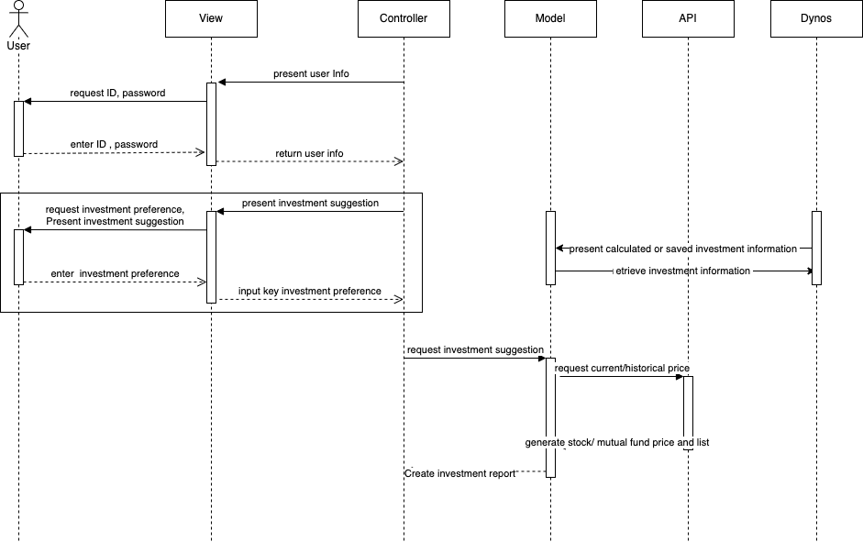

### Data requirements

Data requirements definition establishes the process used to identify, prioritize, precisely formulate, and validate the data needed to achieve predicting and advising objectives.

##### 

##### Data Used in API

Aphap Vantage API returns intraday time series of the equity specified, covering extended trading hours where applicable (e.g., 4:00am to 8:00pm Eastern Time for the US market). The intraday data is derived from the Securities Information Processor (SIP) market-aggregated data. You can query both raw (as-traded) and split/dividend-adjusted intraday data from this endpoint

##### 

##### Data used in LSTM model

ENB.TO starts from 2016-01-01 to 2022-11-18

ENB.TO is the stock symbol for Enbridge Incorporated on the Toronto Stock Exchange (TSX).

Enbridge Incorporated is a Canadian multinational energy transportation company based in Calgary, Alberta. It focuses on the transportation, distribution and generation of energy, primarily in North America.

SU.TO starts from 2016-01-01 to 2022-11-18

Suncor Energy is a Canadian integrated energy company based in Calgary, Alberta. It specializes in production of synthetic crude from oil sands

##### Data used in Mutual fund

The Globe and Mail offers the most authoritative news and data in Canada, featuring corporate data, and national and international news. Company stock data. The most comprehensive database of Canadian corporate financial information in spreadsheet format. The information allows you to better understand the top companies in Canada, to make it easier to sell to, invest in and communicate with these companies.

### Performance requirements

The chatbot shall be able to process 1 investment suggestion request per 35 second in peak load.

In standard workload, the CPU usage shall be less than 30%, leaving 70% for background jobs.

Production of an investment report shall take less than 30 seconds for 95% of the cases.

Scrolling chat history in a 50 lines chat shall take at most 4 seconds.

LSTM model shall process one prediction in less than 75 seconds.

Mutual fund OR stock Excel made by API request less than 25 seconds

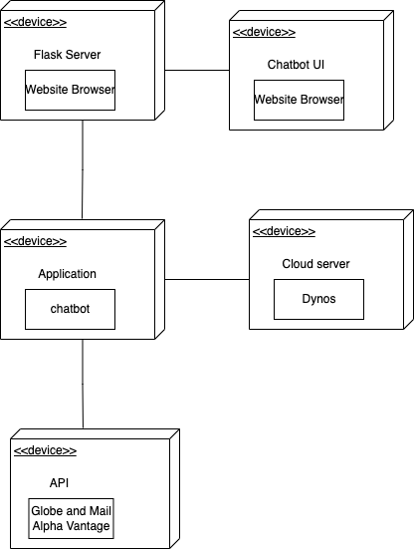

### Security requirements

Security and privacy is always the top priority of an application. Security requirements ensure users’ credential is encrypted and chat conversation is only alive by sessions. RoboAdvisor currently don’t save the investment recommendation in users’ profile, so database security is out of this project scope.

Users’ password is hashed when registering a new account or changing the existing password and it is saved in sqlite, which is not exposed externally. Chat history is only visible to the current user when the chatting session is active. Once users leave the conversation or log out, the chat history will be destroyed.

### Maintenance & support requirements

Maintenance procedure shall be a code review, with a checklist to ensure conformity to company-wide standards. 70+% of the code must obtain “high maintainability”.

No method or object shall exceed 40 lines of code

Installation of a new version shall leave all database continents and all settings unchanged.

Chatbot shall provide facilities for tracing database fields to places where it's used.

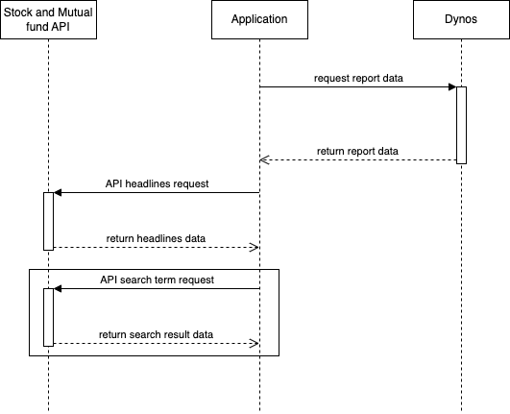

### Operation and environment requirements

The servers have been tested to meet all functional requirements when operating at room temperature. Operating computer equipment in extremes of temperature or humidity increases the failure rate of hardware components. To minimize the chance of component failure, use the server within the optimal temperature and humidity ranges

Software Environment requirements:

ChatterBot 1.0.4

Django 4.1.1

chatterbot-corpus 1.2.0

Flask 2.2.2

Mathparse 0.1.2

Matplotlib 3.6.1

nltk 3.7

yifinance 0.1.87

tensorflow 2.8.0

absl-py==1.0.0  
appdirs==1.4.4  
asgiref==3.5.2  
astunparse==1.6.3  
async-generator==1.10  
attrs==22.1.0  
blessed==1.19.1  
cachetools==5.0.0  
certifi==2021.10.8  
charset-normalizer==2.0.12  
ChatterBot==1.0.4  
chatterbot-corpus==1.2.0  
click==8.1.3  
codefind==0.1.3  
contourpy==1.0.5  
cycler==0.11.0  
Django==4.1.1  
et-xmlfile==1.1.0  
exceptiongroup==1.0.0rc9  
Flask==2.2.2  
flatbuffers==2.0  
fonttools==4.38.0

## Design

### Home Page

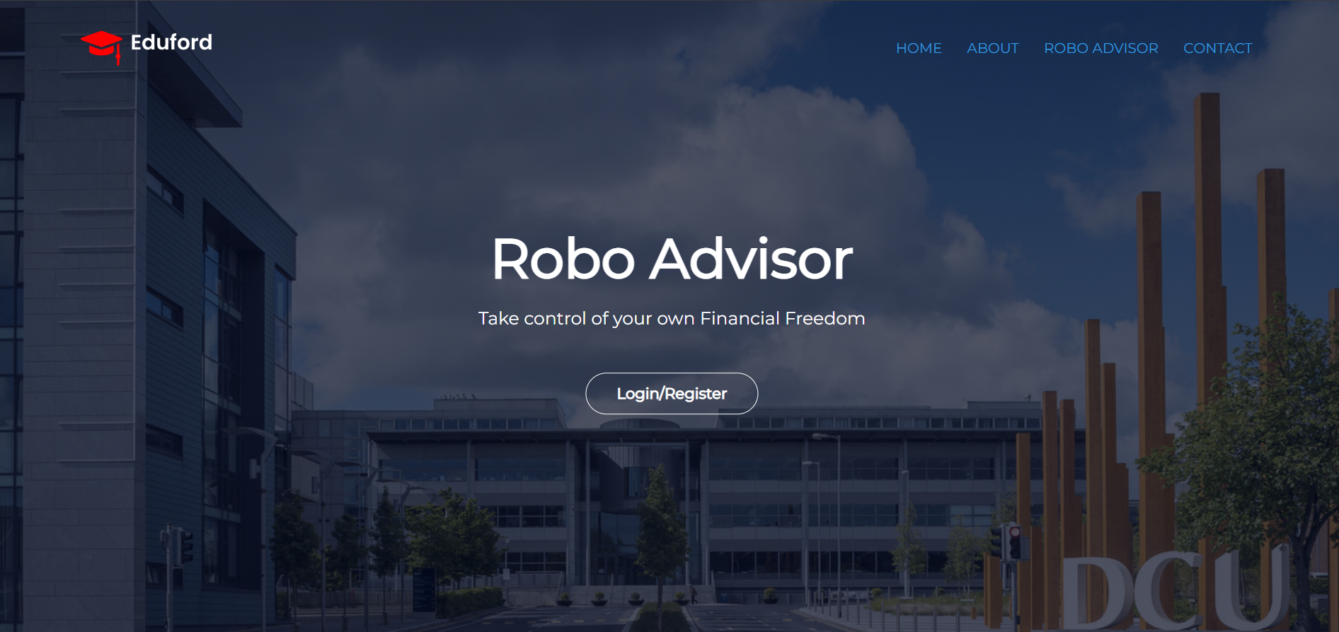

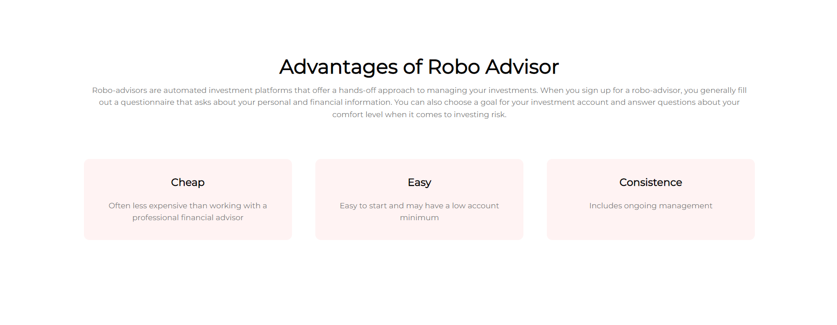

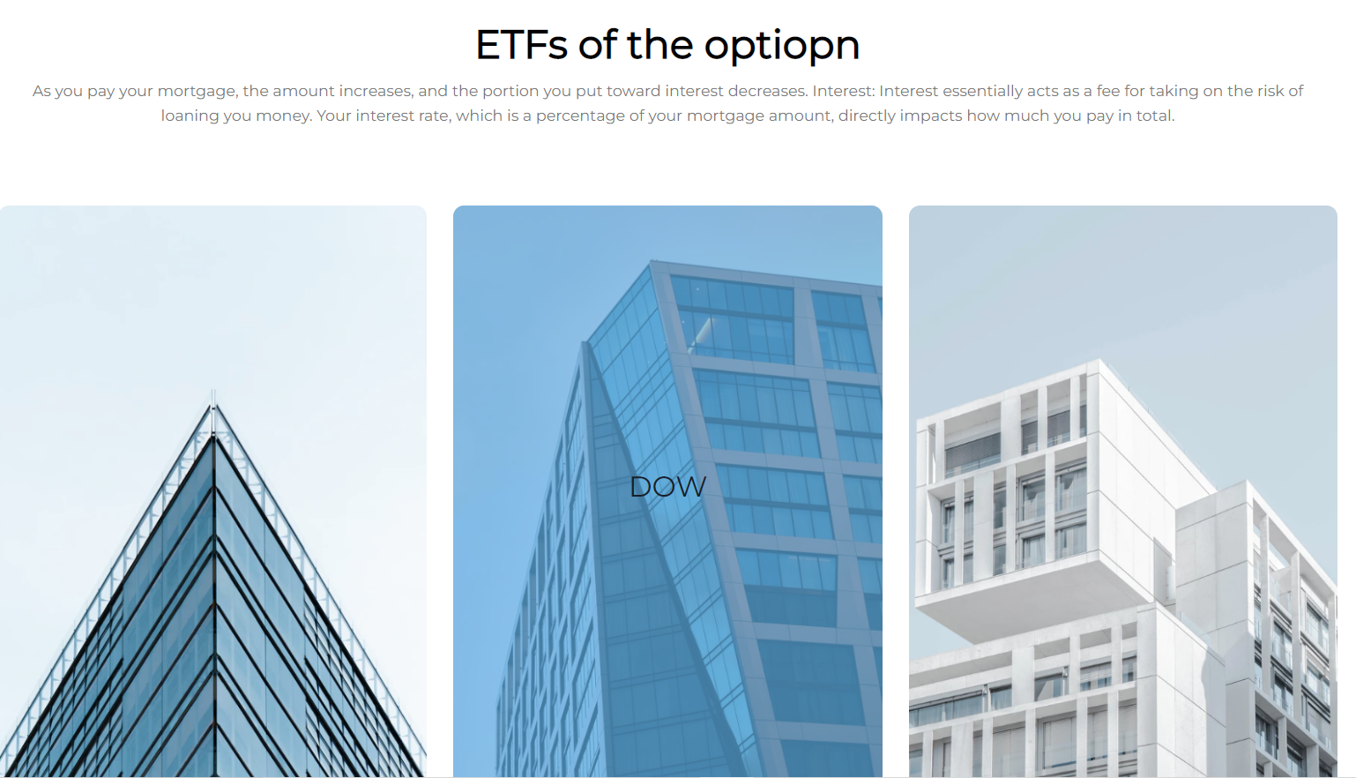



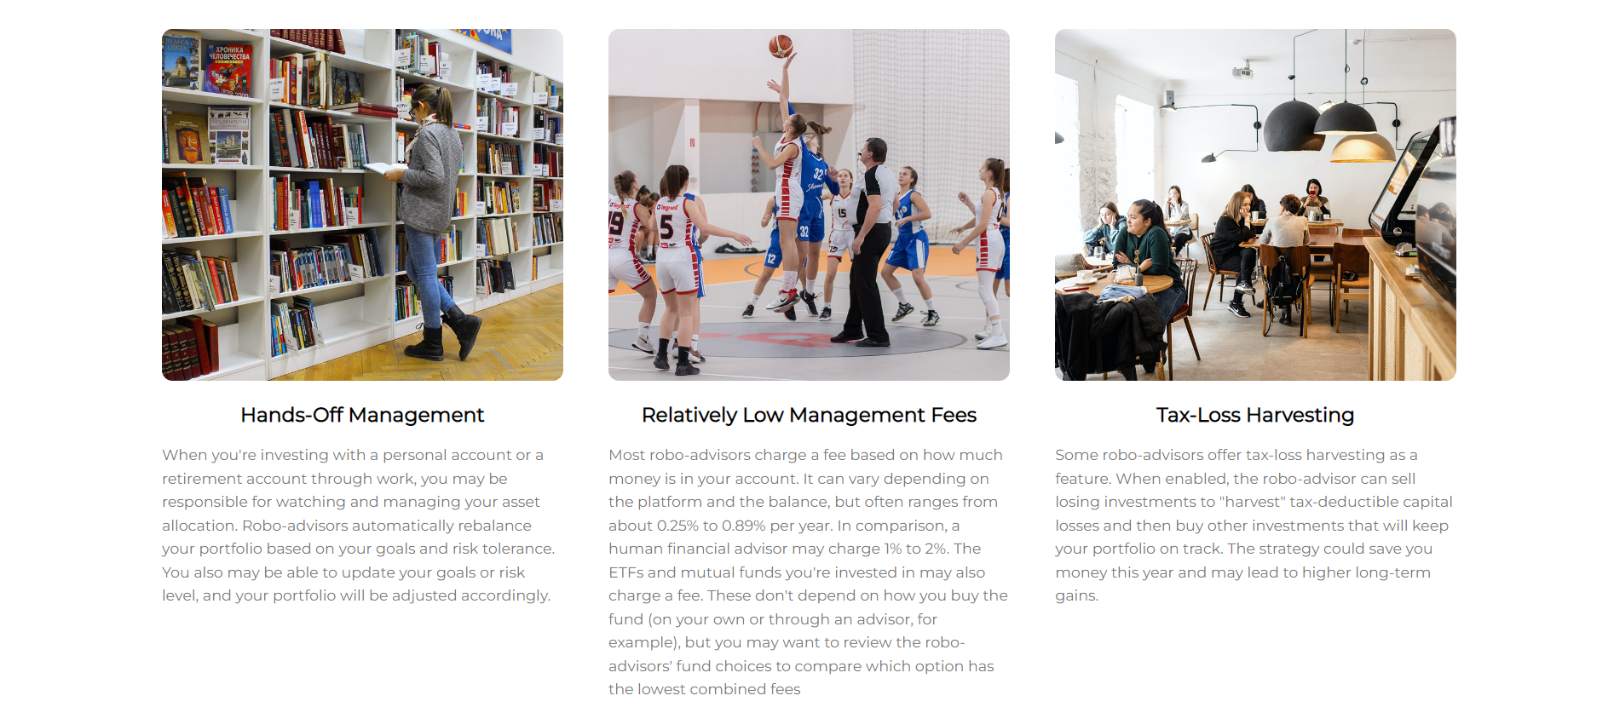

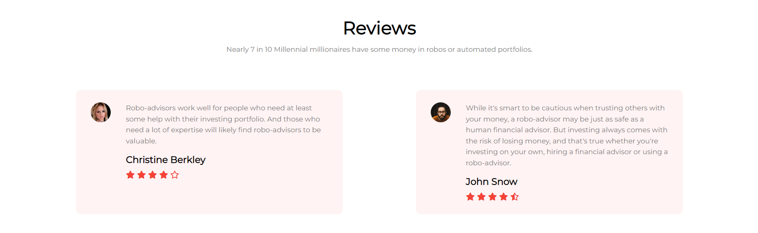



### About us page



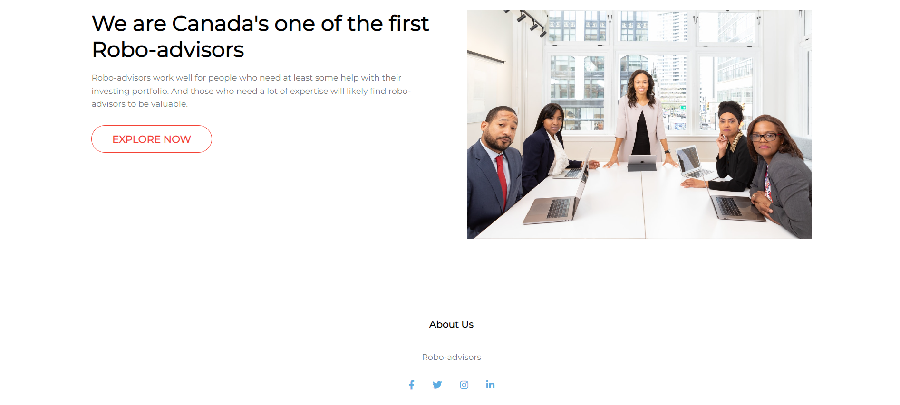

### Contact us page



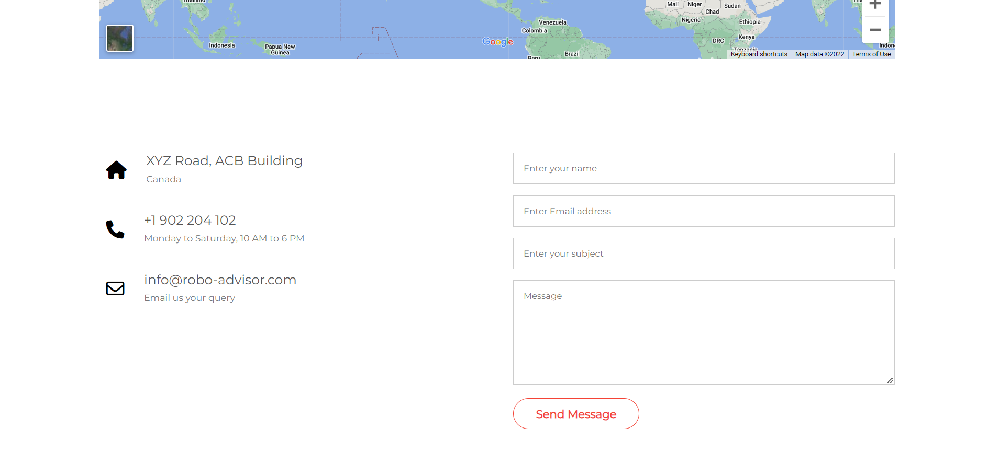

### Login/Register pages

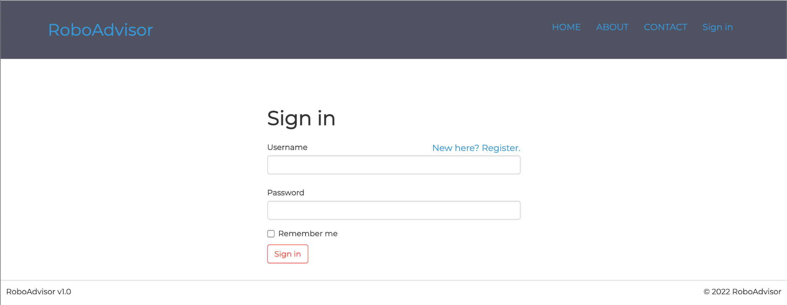

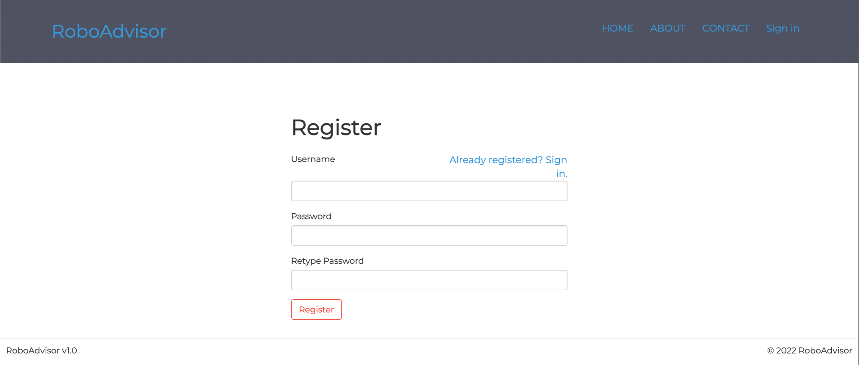

### Chat page

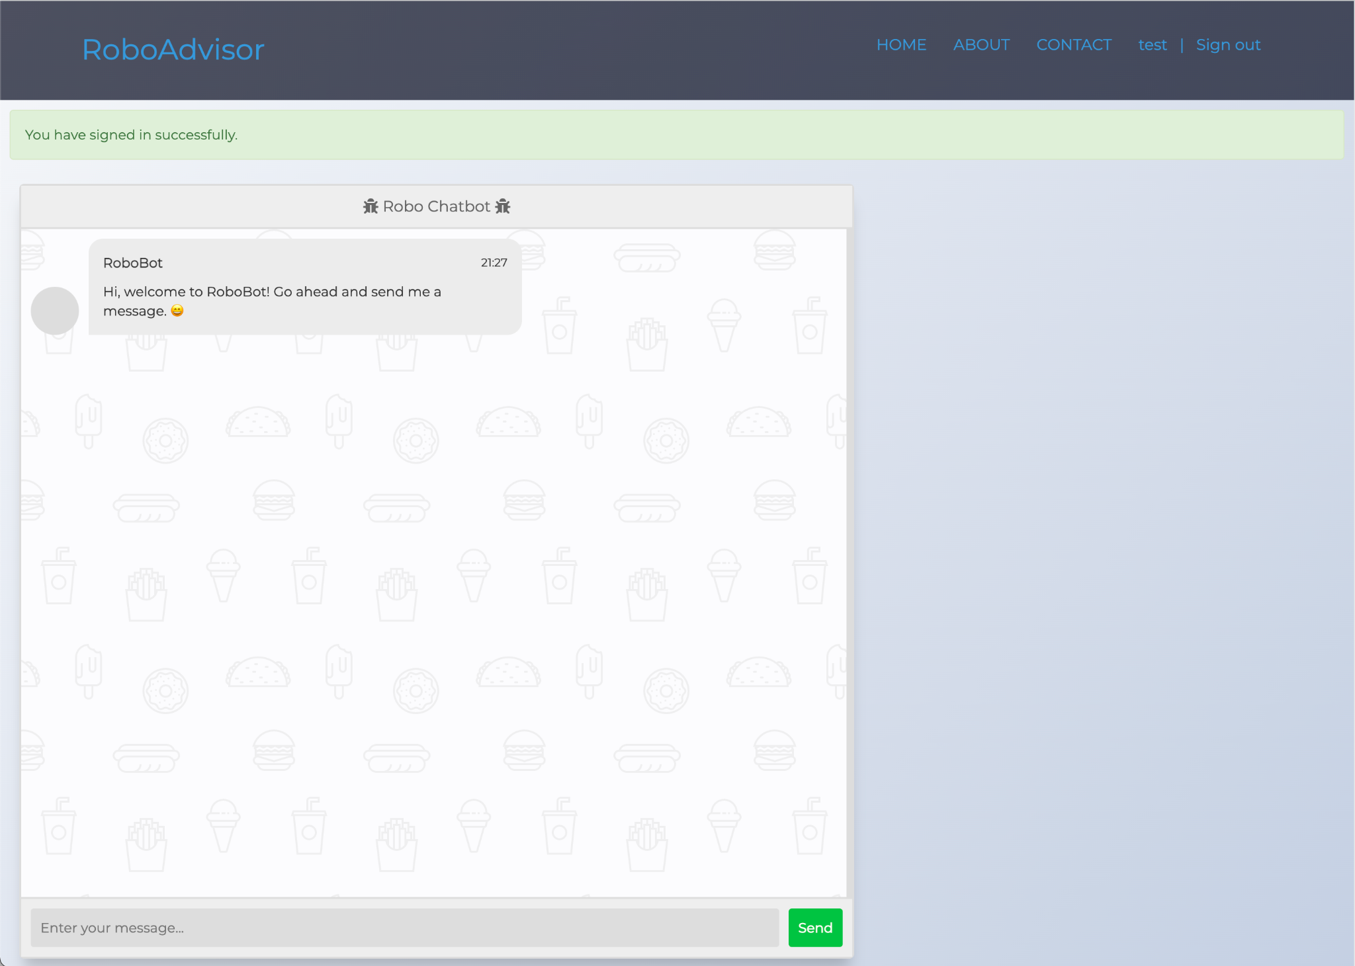

## Test cases

Testing conversation with RoboAdvisor

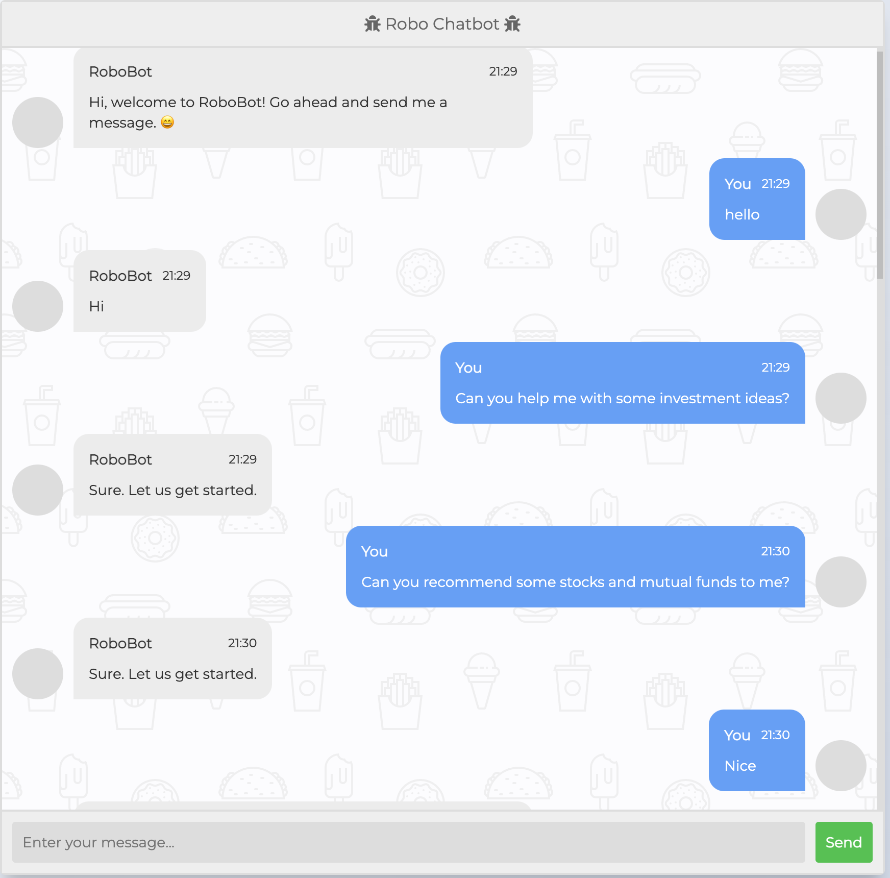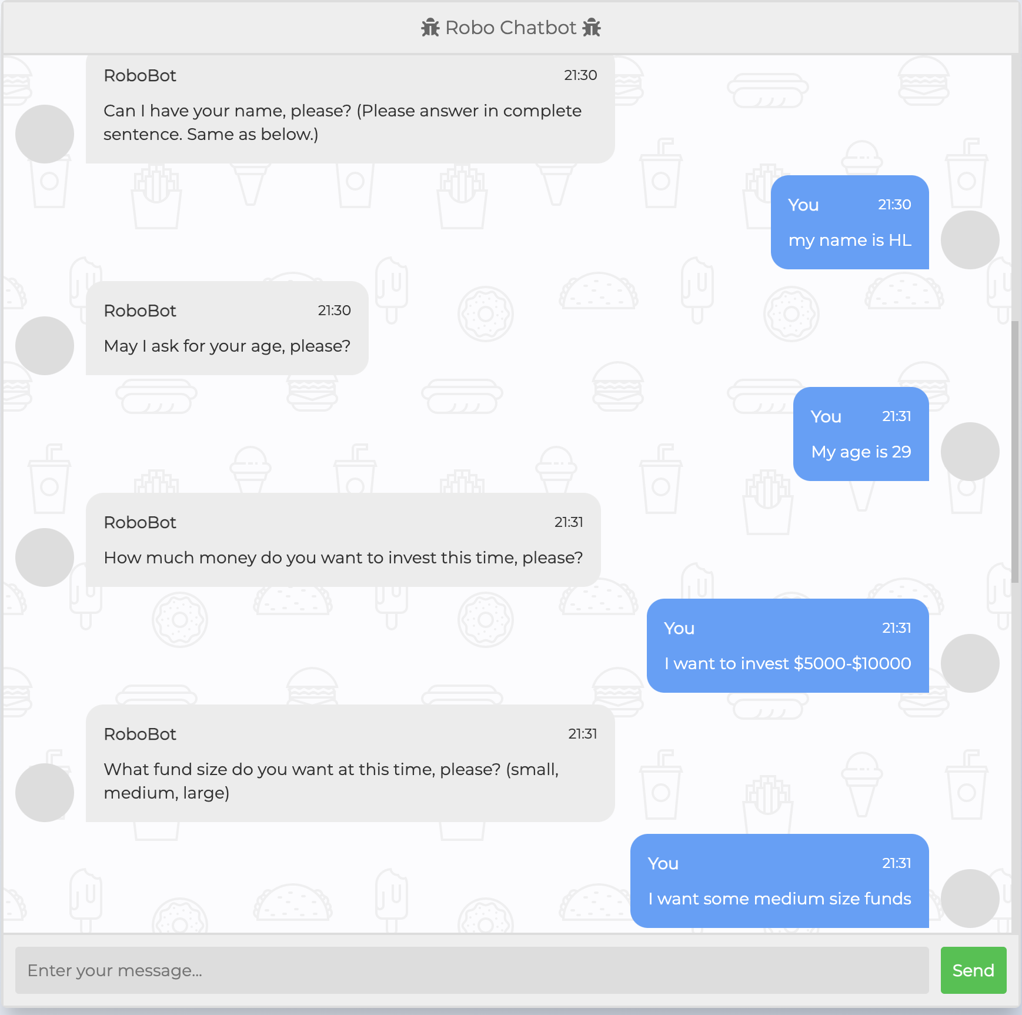

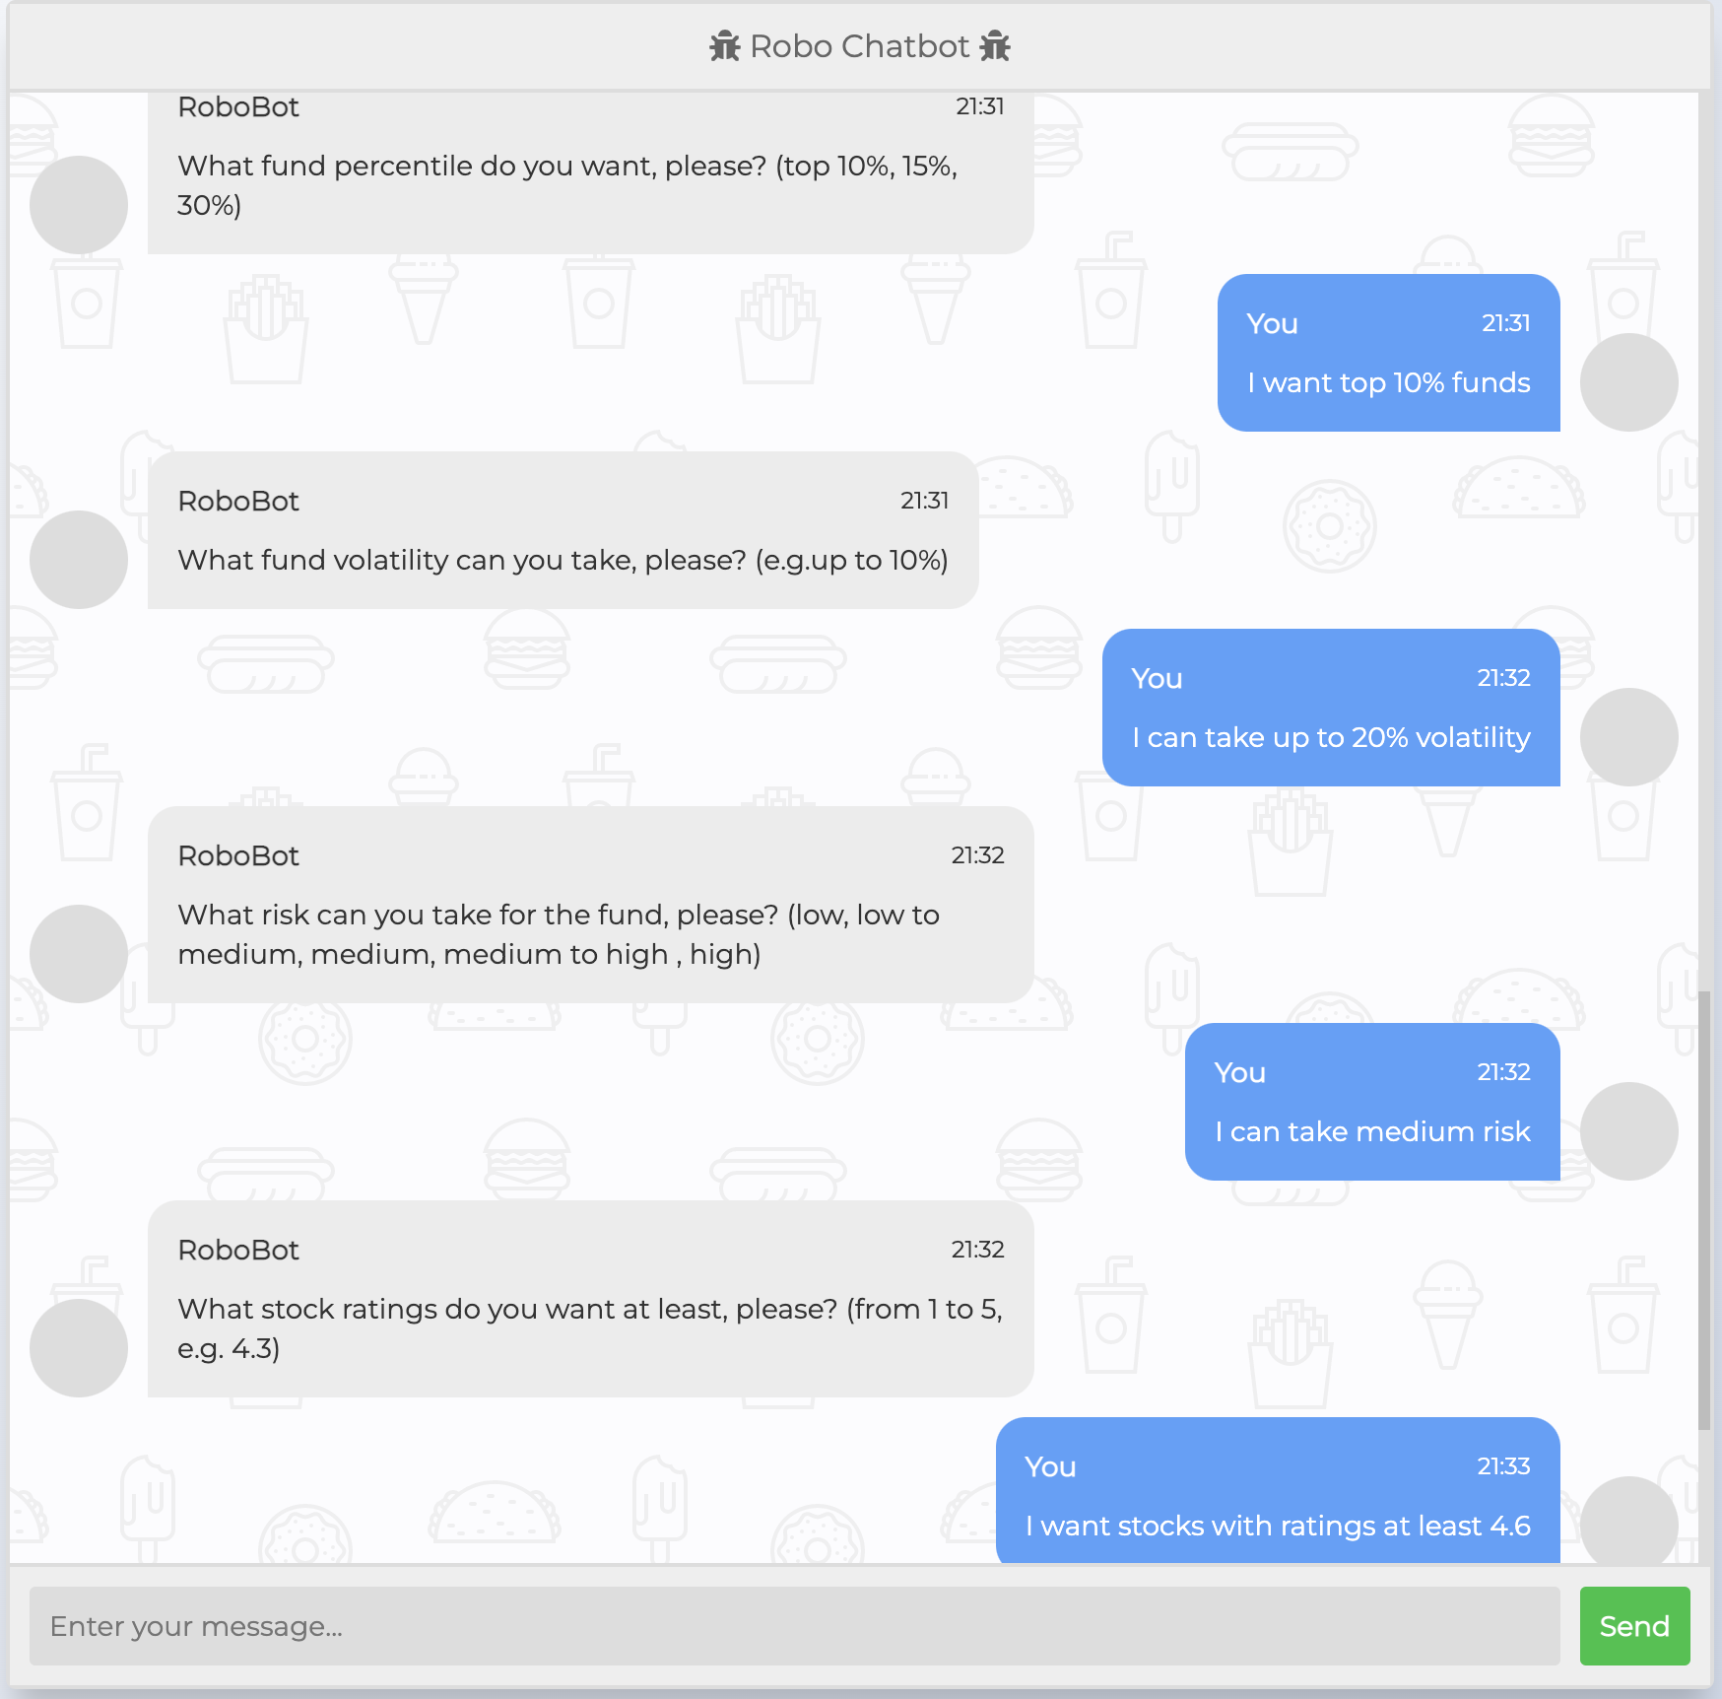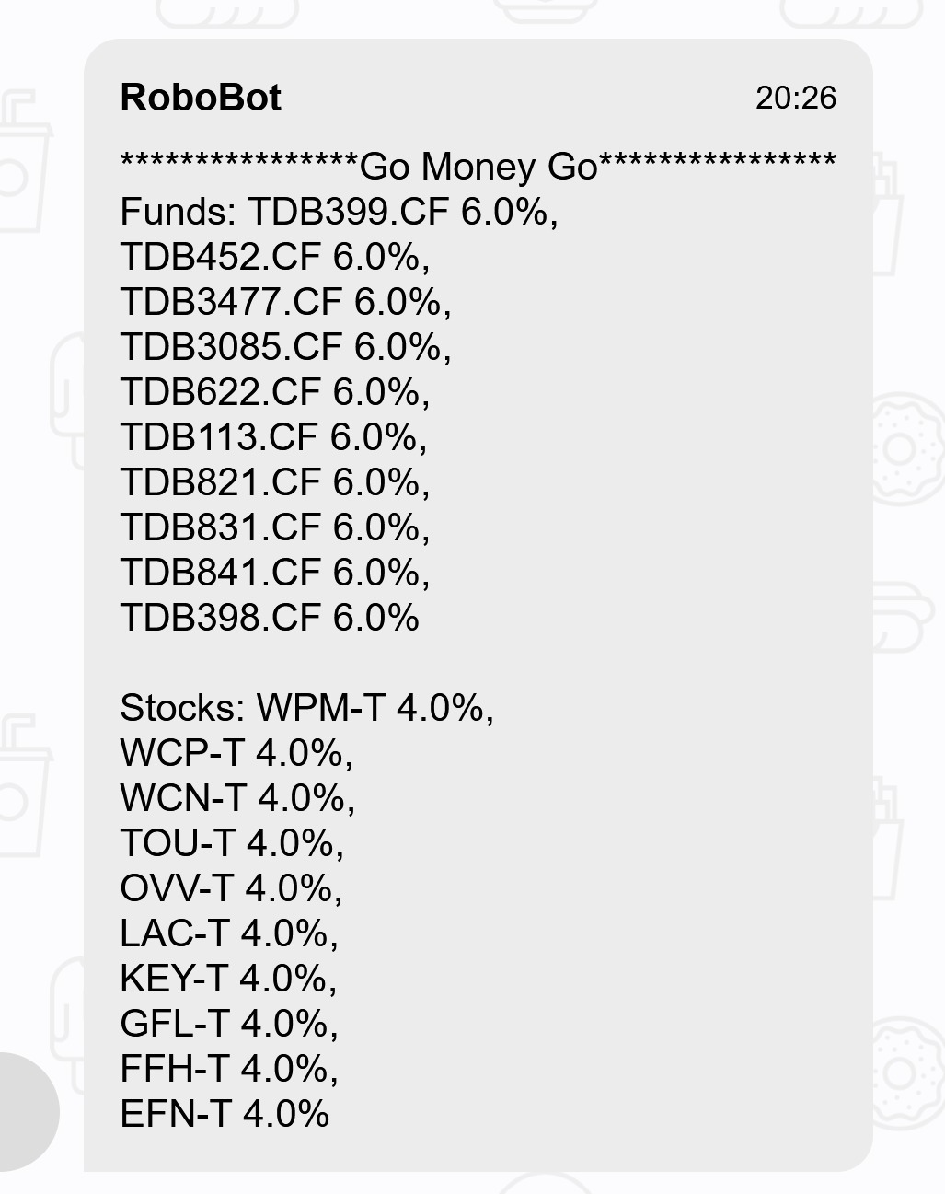

Test 1: Stock Recommendation CSV List

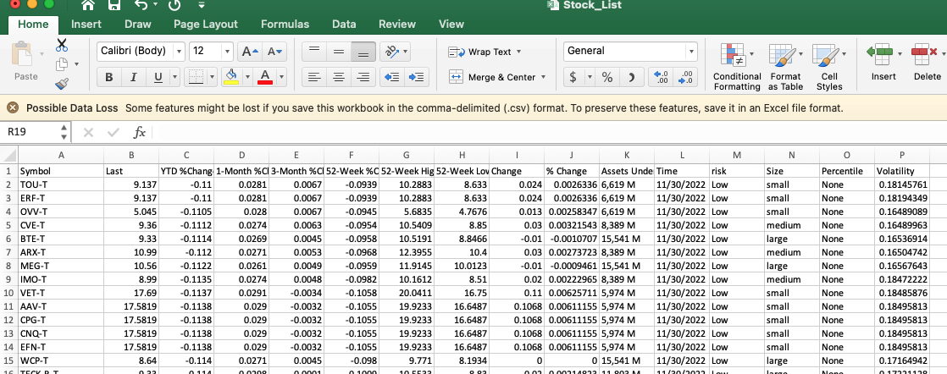

Test 2: Mutual Fund Recommendation CSV List

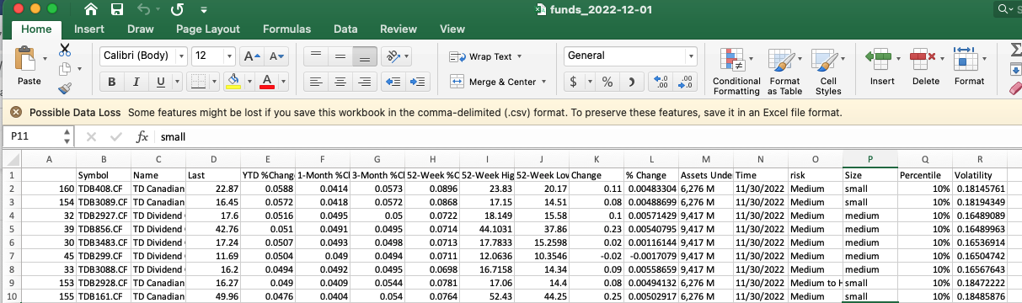

Test 3: LSTM Prediction

We extracted 80% of the closing prices from our acquired stock data as our training set and use 20% of the closing prices to test the prediction of LSTM model. Example stocks are Tesla, Apple, and Nvidia.

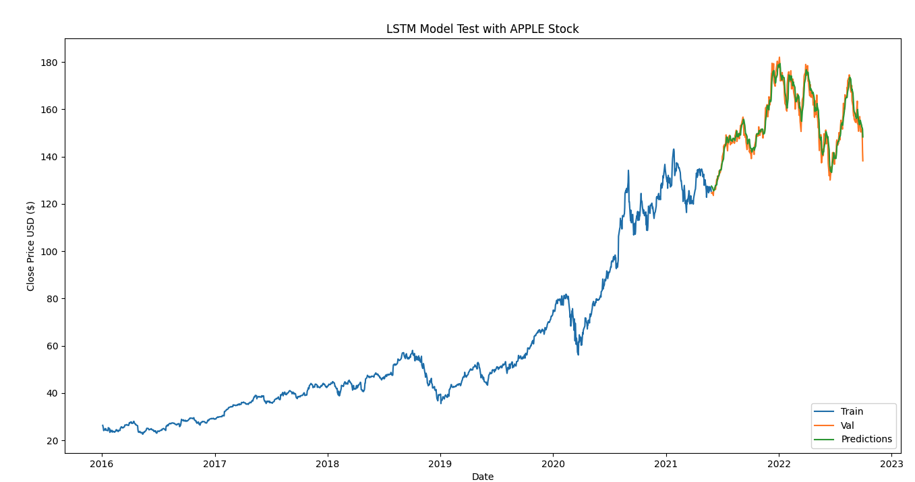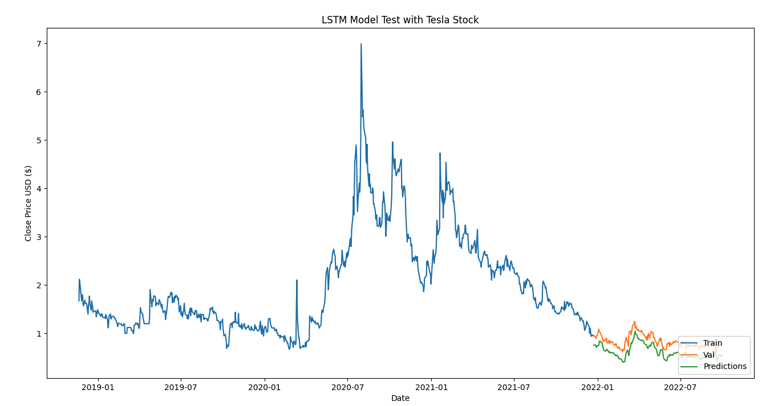

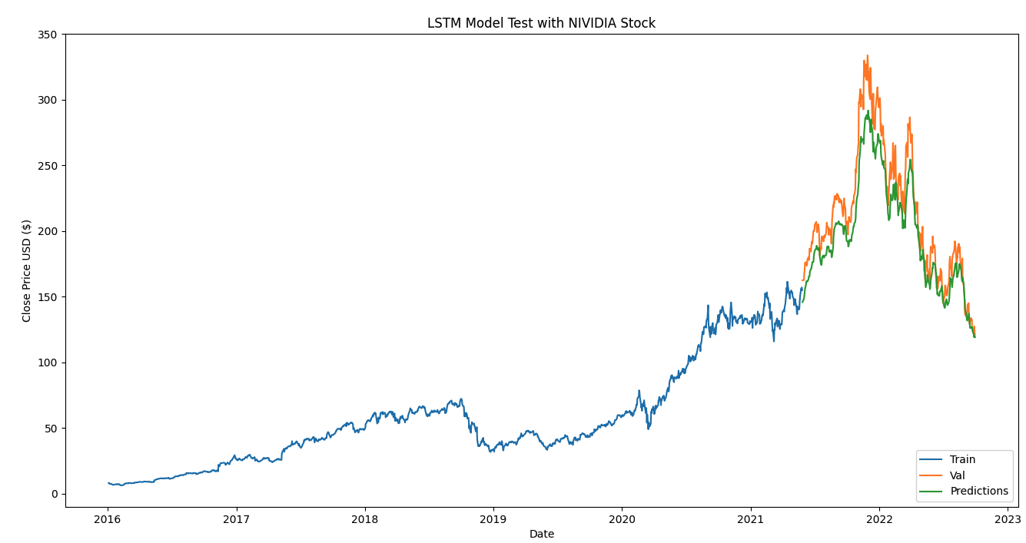

## Issues

1. **Cloud deployment** - We face critical technical difficulties when deploying our app to cloud platform. Multiple platforms like pythonanywhere, AWS, and heroku have been tried. However, all of them failed installing python package due to dependencies version conflicts and python env. The blocker persists even we have made the env close to our local env. Due to this blocker, we publish our localhost to public when demoing our app by using ngrok tool.
2. **Teamwork**- Team members have different working schedules, programming experience, point of interest, and personality. It's challenging to put everyone on the same page without conflicting.
3. **Mutual fund API data**. There are not many free mutual fund data API resources. Data training on LSTM for mutual funds is difficult. We solved this issue by subscripting Global Mail API service.

## Ethics and sustainability considerations

* This software is provided to all races and all genders
* Respect users’ privacy, RoboAdvisor doesn’t save user information without consent
* Digitalize traditional investment advising, less paper used
* Give proper credit for intellectual property
* Maintaining Objectivity/Truthfulness
* Addressing Conflict of Interest
* Preserving Confidentiality
* Receiving and Providing Valuable Consideration
* Contribute to society and human well-being

## Commercialization

|  | 1. **Importance** | 1. **Innovation** | 1. **Competition** |
| --- | --- | --- | --- |
| **Rank (1-10)** | **Rank: 5**  Professional investors have all kinds of tools. But we provide an easy-use solution for the average population to get investment suggestions. | **Rank: 7**  This automated and customized solution could be the mainstream service type in the future financial industry. | **Rank: 4**  Cheaper, Easier to use, Performs faster and consistently. Special features (coming)  At the first release stage, the value we can provide to the users might be limited. But this business model could win. |

**We are considering two ways of commercialization for our project:**

1. **Subscription**

Users can use the trial version free of charge. To access advanced features such as user accounts and stock investment recommendations, Users need to subscribe and pay a monthly fee.

1. **Source Code Package**

We can also sell this chatbot software with customized AI algorithms to other vendors and commercial websites.

An yearly fee determined as a percentage of assets under management makes up the majority of what customers pay for investment advice. This charge normally varies from 1% to 2% of the assets under management for conventional advisers. Therefore, the charge for a $100,000 portfolio would be $1,000 to $2,000 every year.

On the other hand, Robo-advisors typically charge about 0.50% of assets managed. A $100,000 portfolio, for instance, would only cost $500 a year. To put things in perspective, conventional advisers often charge 1% to 2% of assets handled, which translates to $1,000 to $2,000 per year for a $100,000 account. Many conventional advisers also charge supplemental account fees, some as high as $3,000, and hourly prices for financial advisor assistance. As you can see, traditional advisers charge fees that are more than twice as high as those of robo-advisors.

## Conclusions

The RoboAdviosr project aims to provide non-professional investors with reliable investment recommendations for Canadian stocks and mutual funds. The front end uses a customized trained robot based on the Python chatterbot module. Users chat with the bot on the webpage to tell their preferences and get their investment recommendation in the end. The backend algorithms will combine user inputs to search in the updated product pool and generate a matching recommendation list. Based on some financial knowledge research, we also tailor the weight in the package of individual stock and funds products.

In this project, we combined various data engineering and frontend development techniques such as Flask framework, web data scraping, and data integration and realized the auto data process. Furthermore, we applied an LSTM AI model to predict the top-return stocks. To make the project more feasible, we used pre-selected 100 stocks and 200 mutual funds data retrieved from a subscription on the Globe and Mail website. Staff could automatically update data running separate backend scripts.

## Appendix